Ecology and Evolution

SUPPORTING INFORMATION

Islands in the desert for cavity-nesting bees and wasps: ecology, patterns of diversity, and conservation at oases of Baja California peninsula

Armando Falcón-Brindis, María Luisa Jiménez Jiménez & Ricardo Rodríguez-Estrella

Appendix S1. Characterization of oases according to the degree of human impacts.

Table S1. Anthropogenic variables associated to human impacts. Variables were transformed and weighted for multidimensional analyses. SA=Santiago, EP=El Pilar, LP= La Purísima, ES=El Sauzal, SB=San Borja, SF=San Fernando. Variables were standardized and then weighted considering the land-use change as the highest impact variable (following Mantorell & Peters, 2005).
Variable | SA | EP | LP | ES | SB | SF
Human population | 800 | 15 | 500 | 10 | 10 | 0
Population density (ind/ha) | 5.4 | 1 | 1.9 | 0.5 | 1.6 | 0
Land-use change (%) | 90 | 65 | 60 | 40 | 75 | 20
Dist. to nearest settlement (km) | 6.7 | 13.3 | 29.1 | 11.3 | 28.3 | 47.6
Dist. to paved road (km) | 0.01 | 11.8 | 0.01 | 0.2 | 25.3 | 1.8
Agriculture (%) | 70 | 60 | 35 | 40 | 70 | 0
Alien crops* | 7 | 6 | 8 | 11 | 6 | 0
Pesticides use | Frequent | Occasional | Frequent | Seldom | Seldom | Seldom
Livestock (ranching) | Frequent | Occasional | Frequent | Seldom | Seldom | Frequent
Slash-and-burn method | Frequent | Occasional | Frequent | Occasional | Seldom | Occasional
* Angiosperm plants only.

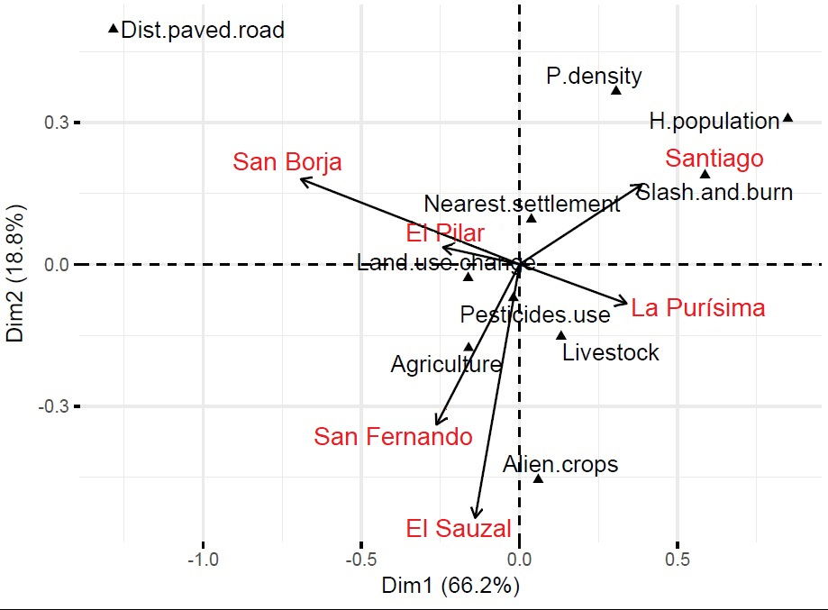
Figure S1. Canonic correspondence analysis showing human impacts and their effects among studied oases.

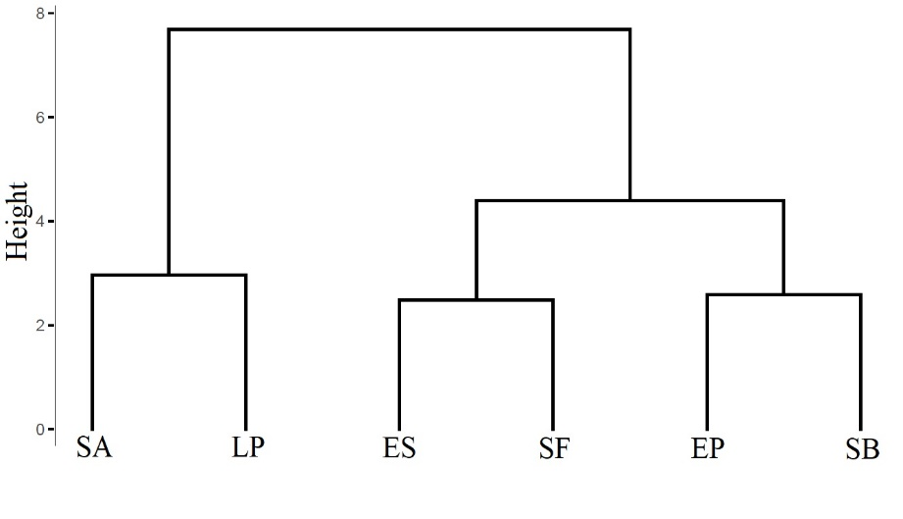
Figure S2. Cluster analysis in correspondence to the degree of human alteration. K=3. SA=Santiago, EP=El Pilar, LP= La Purísima, ES=El Sauzal, SB=San Borja, SF=San Fernando.

Appendix S2. We present the general steps taken to build the models. Comparisons between models for bees and wasps considered the values of lowest AICc (Second-Order Akaike Information Criterion for small samples) and the highest explained deviance, starting from a null model (Bates et al. 2015). We followed the step forward technique, incorporating those variables with biological meaning and statistical significance to the models (Zuur et al. 2009). (Table S1).

Table S1. Example of model selection explaining the nest abundance of bees and wasps. The △AICc value is with respect to the null model. During the selection, the minimum adequate models considered △AICc > 2 units (Zuur et al. 2009).
 |  | Bees |  |  | Wasps
Model | Type of model | AICc | △AICc | Deviance | AICc | △AICc | Deviance
1 | Null | 346 | - | 342 | 328.3 | - | 324.3
Selected model | Response variable ~ Fixed effects + (random effect) | 328.7 | 0 | 320.7 | - | 0 | -
Selected model | Response variable ~ Fixed effects + (random effect) | - | - | - | 290 | 38.3 | 278

References
Bates, D., Maechler, M., Bolker, B., & Walker, S. (2015) Fitting Linear Mixed-Effects Models Using lme4. Journal of Statistical Software, 67, 1-48.
Mantorell, C., & Peters, E. M. (2005). The measurement of chronic disturbance and its effects on the threatened cactus Mammillaria pectinifera. Biological Conservation, 124, 199–207.
Zuur, A. F. Ieno, E. N., Walker, N. J., Saveliev, A. A., & Smith, G. M. (2009). Mixed effects models and extensions in ecology with R. New York, NY: Springer.

